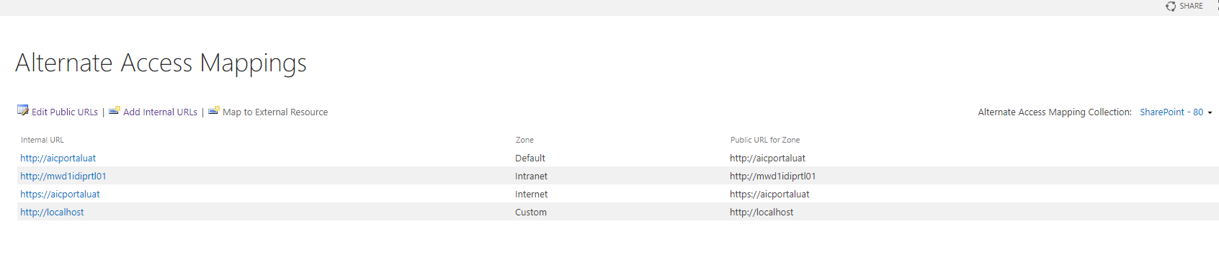

**Common paths:**

[http://mwd1idiprtl01/ar/Pages/Forms/AllItems.aspx#](http://mwd1idiprtl01/ar/Pages/Forms/AllItems.aspx)

--deploy wsp (user controls & web parts)

C:\Program Files\Common Files\microsoft shared\Web Server Extensions\16\TEMPLATE\CONTROLTEMPLATES

------------------------------

--accessed by url

/_layouts/15/{folder name}/{filename}

http://localhost/_layouts/15/investmentassets/test.txt

C:\Program Files\Common Files\microsoft shared\Web Server Extensions\16\TEMPLATE\LAYOUTS

----------------

pc name:

MWD1IDIPRTL01

-----------------

site contents

http://mwd1idiprtl01/ar/_layouts/15/viewlsts.aspx?view=14

-------------------

scripts

إعدادات الموقع

الصفحات الرئيسية وتخطيطات الصفحات

Internal Portal

libs>>>

http://mwd1idiprtl01/_catalogs/masterpage/Forms/AllItems.aspx?RootFolder=%2f%5fcatalogs%2fmasterpage%2fInternal%20Portal%2flibs&FolderCTID=0x012000A0057E1ECA7201478C35DB94E0896B86&View=%7bF0700617%2d86D8%2d4F59%2dB580%2dC368EB22E4BC%7d

-----------------

main master poge

AIC_Master_AR.master

http://mwd1idiprtl01/_catalogs/masterpage/Forms/AllItems.aspx?RootFolder=%2f%5fcatalogs%2fmasterpage%2fInternal%20Portal&FolderCTID=0x012000A0057E1ECA7201478C35DB94E0896B86&SortField=FilenameMenuNoLink&SortDir=Asc&View=%7bF0700617%2d86D8%2d4F59%2dB580%2dC368EB22E4BC%7d

---------------

layouts

AIC_Layouts

http://mwd1idiprtl01/_catalogs/masterpage/Forms/AllItems.aspx?RootFolder=%2f%5fcatalogs%2fmasterpage%2fAIC%5fLayouts&FolderCTID=0x012000A0057E1ECA7201478C35DB94E0896B86&SortField=FilenameMenuNoLink&SortDir=Asc&View=%7bF0700617%2d86D8%2d4F59%2dB580%2dC368EB22E4BC%7d

--------

http://mwd1idiprtl01/ar/Gallery/ImageGallery/Forms/AllItems.aspx

GetRootFolders js func

---------------

test page

<http://mwd1idiprtl01/ar/Gallery/>

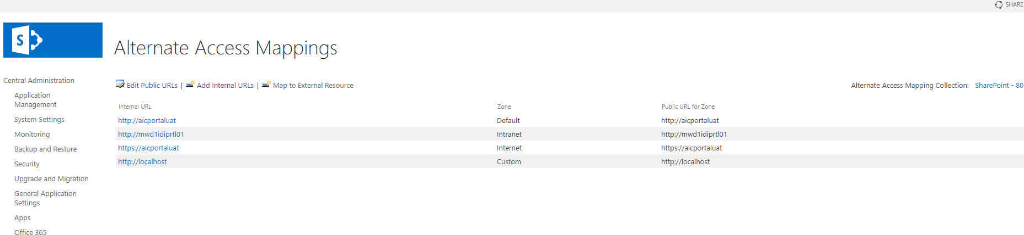

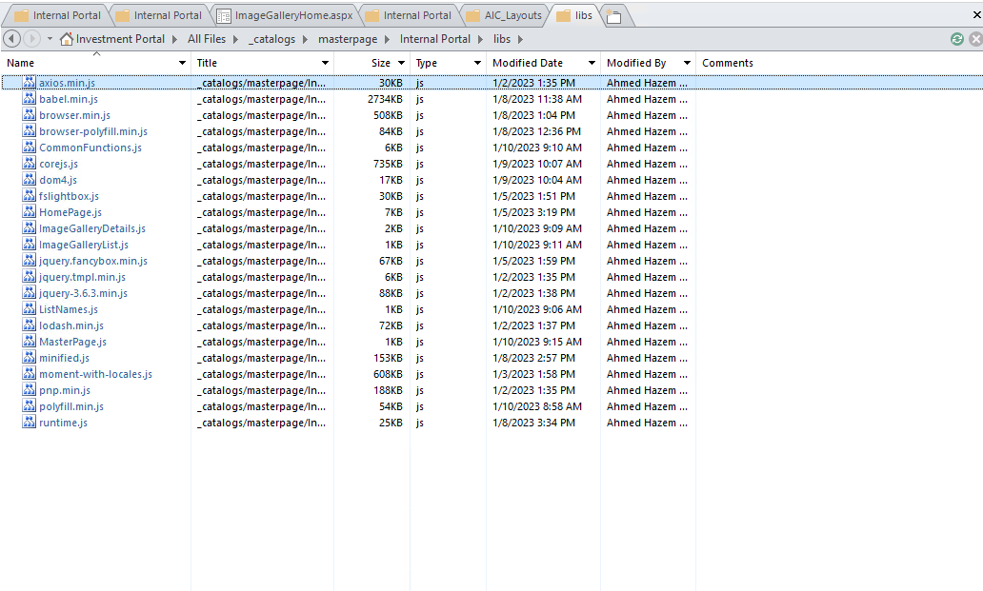

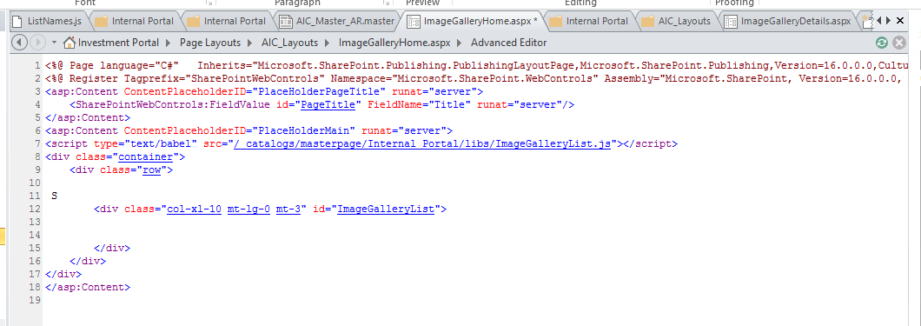

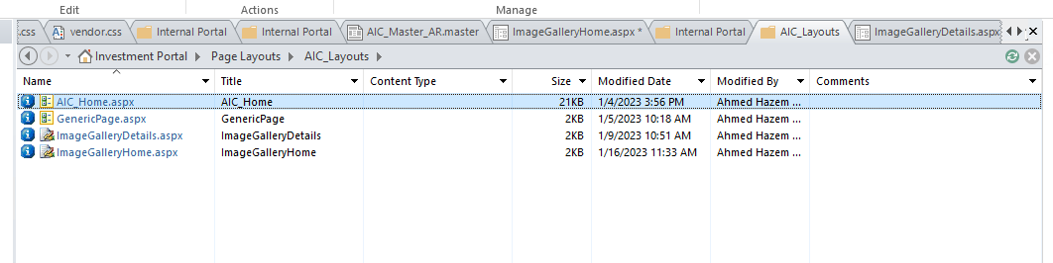

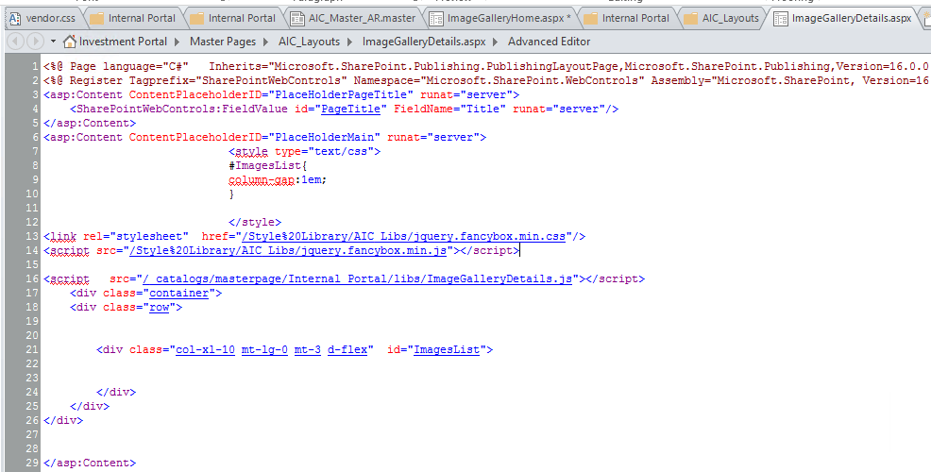

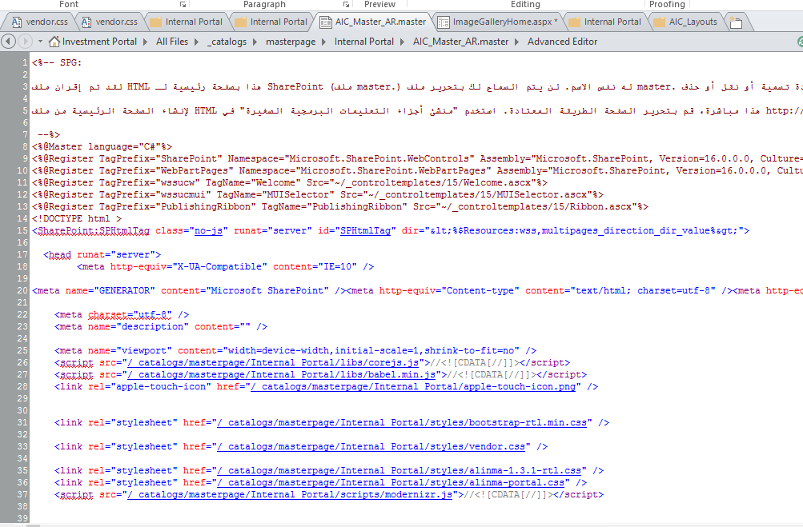

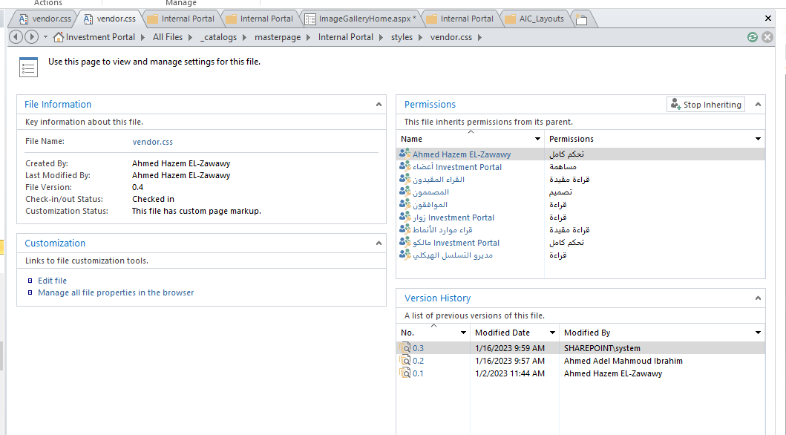

Common paths:

<http://mwd1idiprtl01/_layouts/15/viewlsts.aspx?view=14>

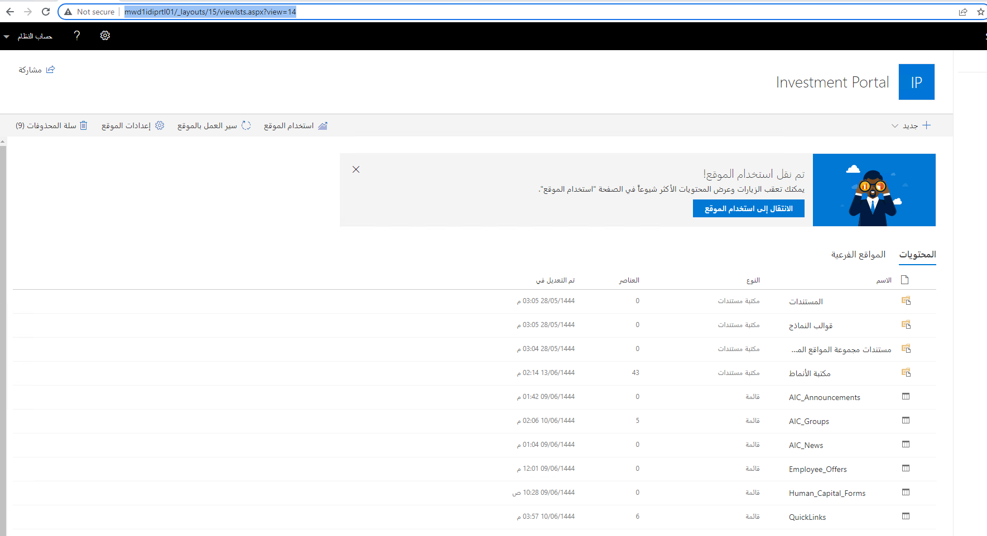

<http://mwd1idiprtl01/Style%20Library/Forms/AllItems.aspx?id=%2FStyle%20Library%2FAIC%5FLibs>

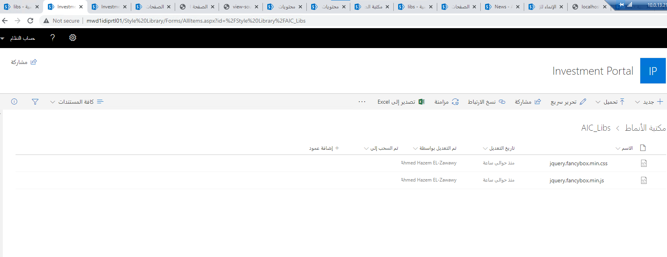

<http://mwd1idiprtl01/ar/Gallery/Pages/Forms/AllItems.aspx>

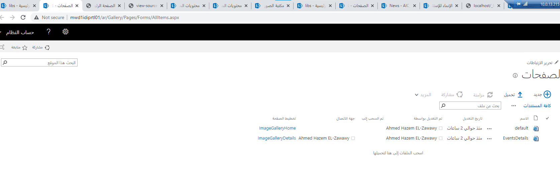

<http://mwd1idiprtl01/ar/Gallery/>

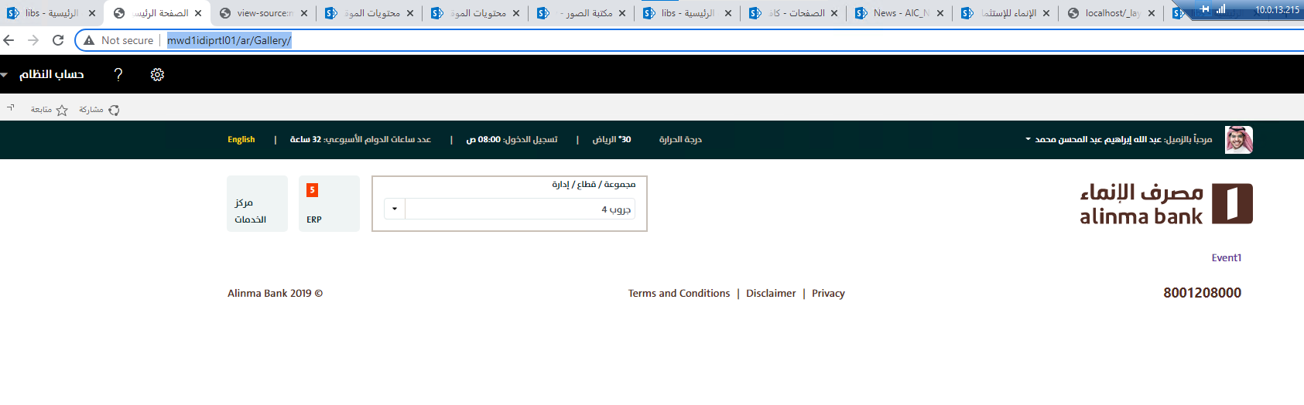

<http://mwd1idiprtl01/ar/Gallery/pages/EventsDetails.aspx?folderUrl=/ar/Gallery/ImageGallery/Event1>

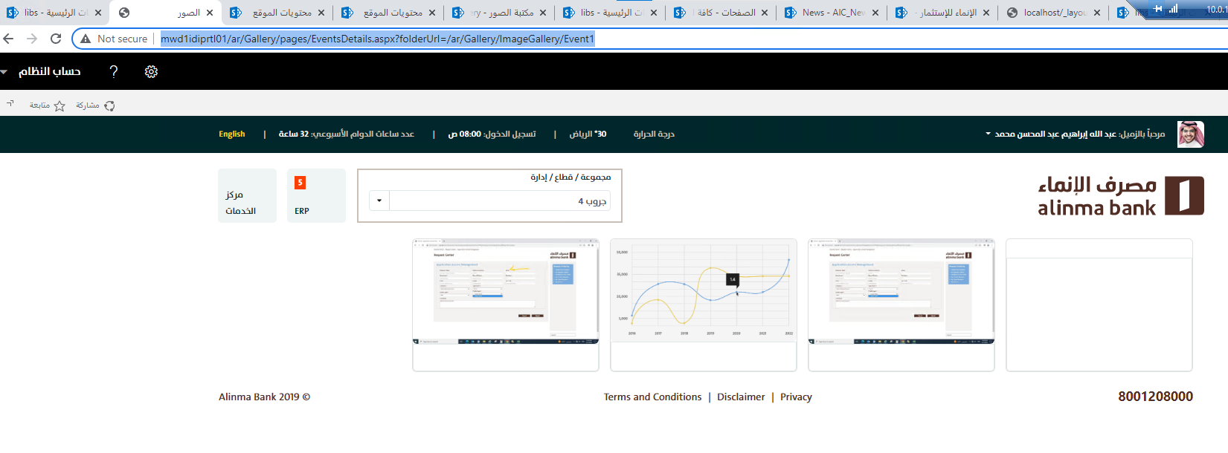

<http://mwd1idiprtl01/ar/_layouts/15/viewlsts.aspx?view=15>

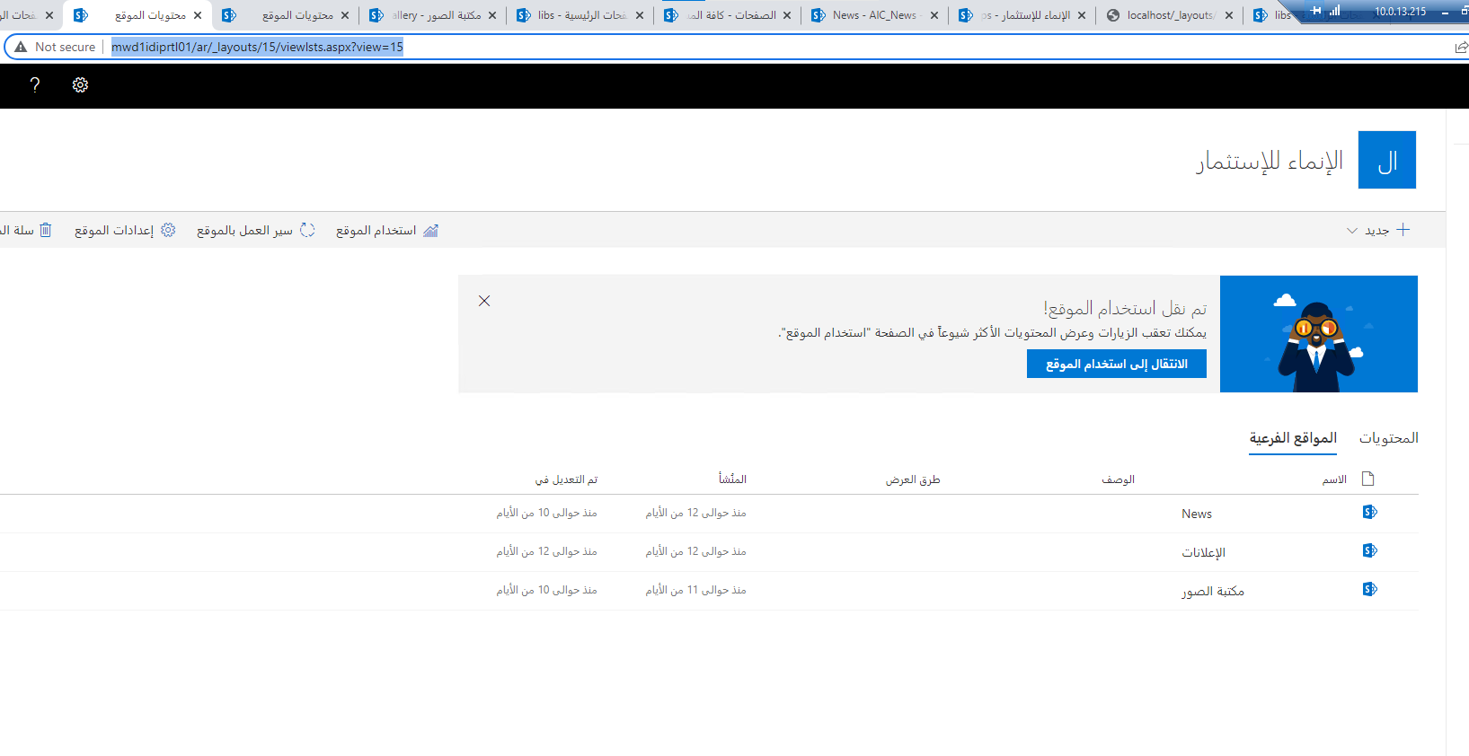

<http://mwd1idiprtl01/ar/Gallery/_layouts/15/viewlsts.aspx?view=14>

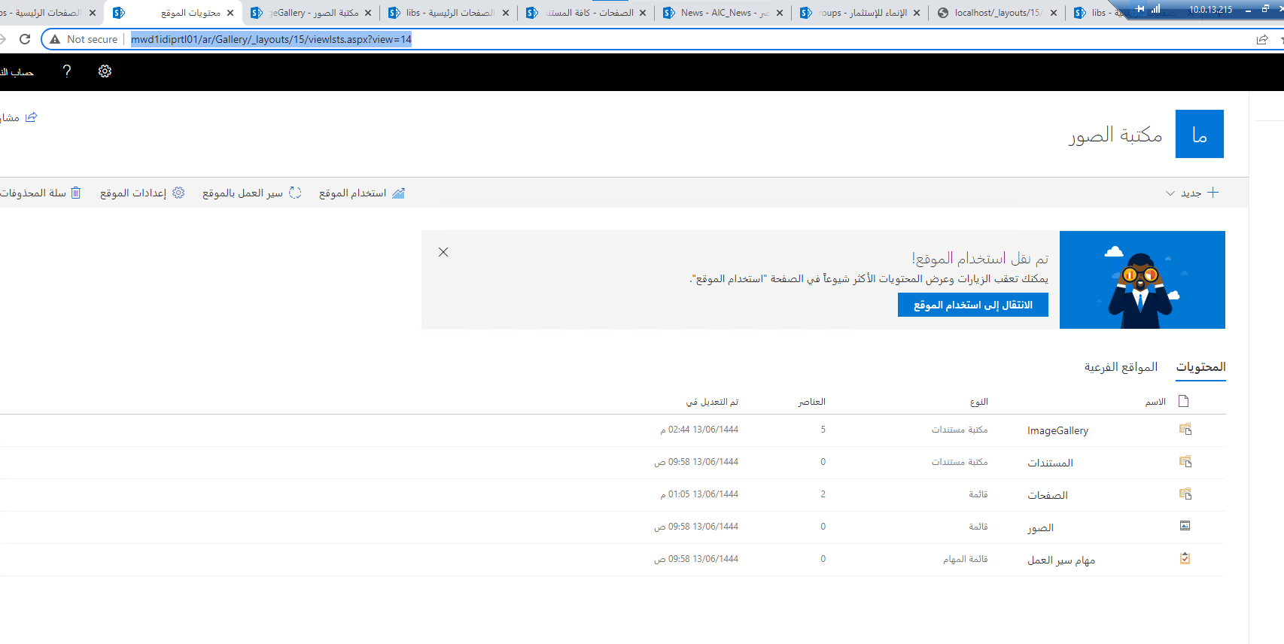

<http://mwd1idiprtl01/ar/Gallery/ImageGallery/Forms/AllItems.aspx>

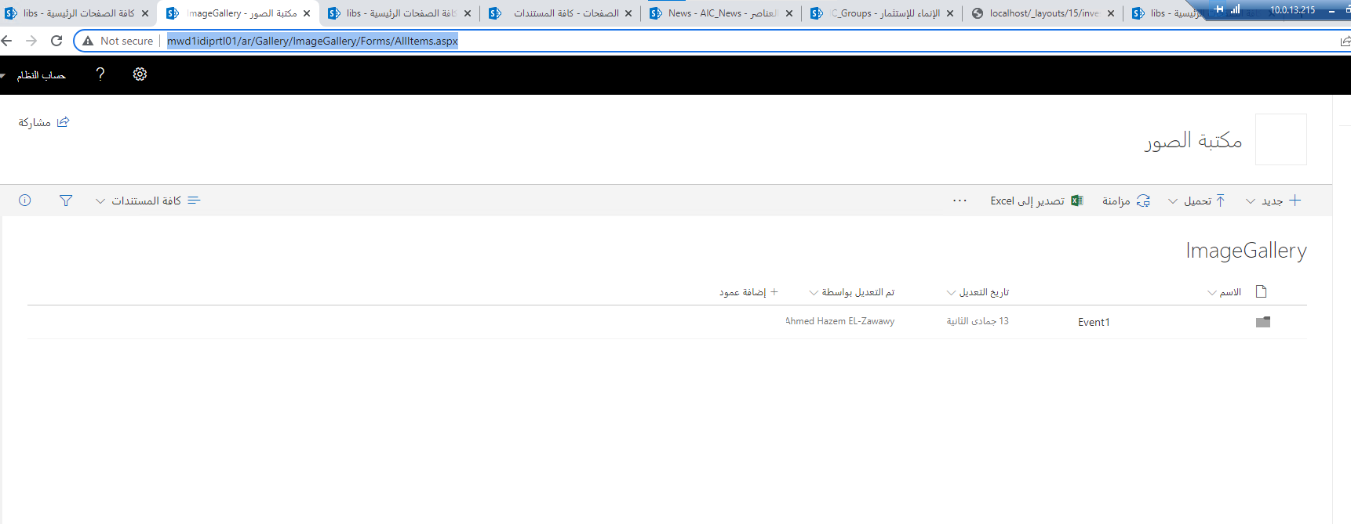

<http://mwd1idiprtl01/_catalogs/masterpage/Forms/AllItems.aspx?RootFolder=%2f%5fcatalogs%2fmasterpage%2fInternal%20Portal%2flibs&FolderCTID=0x012000A0057E1ECA7201478C35DB94E0896B86&View=%7bF0700617%2d86D8%2d4F59%2dB580%2dC368EB22E4BC%7d>

<script type="text/babel" src="/_catalogs/masterpage/Internal Portal/libs/ImageGalleryList.js"></script>

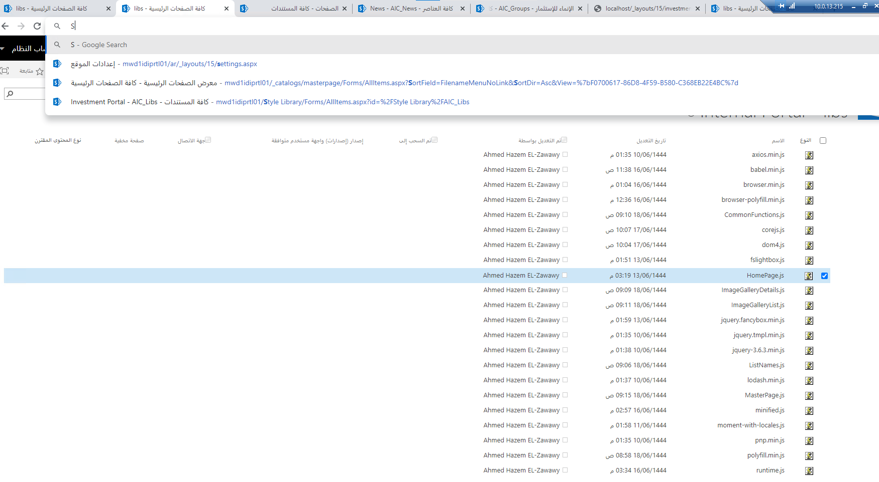

<http://mwd1idiprtl01/ar/news/Pages/Forms/AllItems.aspx>

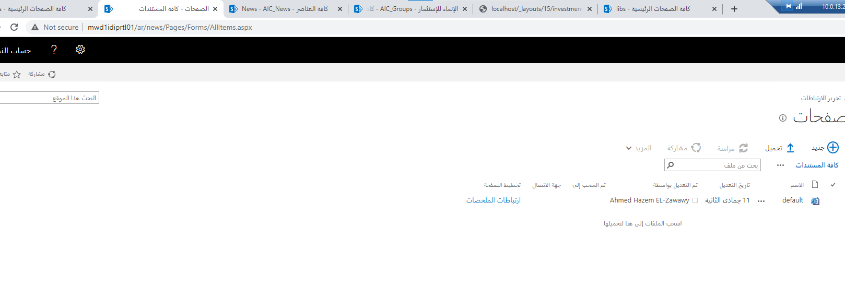

<http://mwd1idiprtl01/ar/news/Lists/AIC_News/AllItems.aspx>

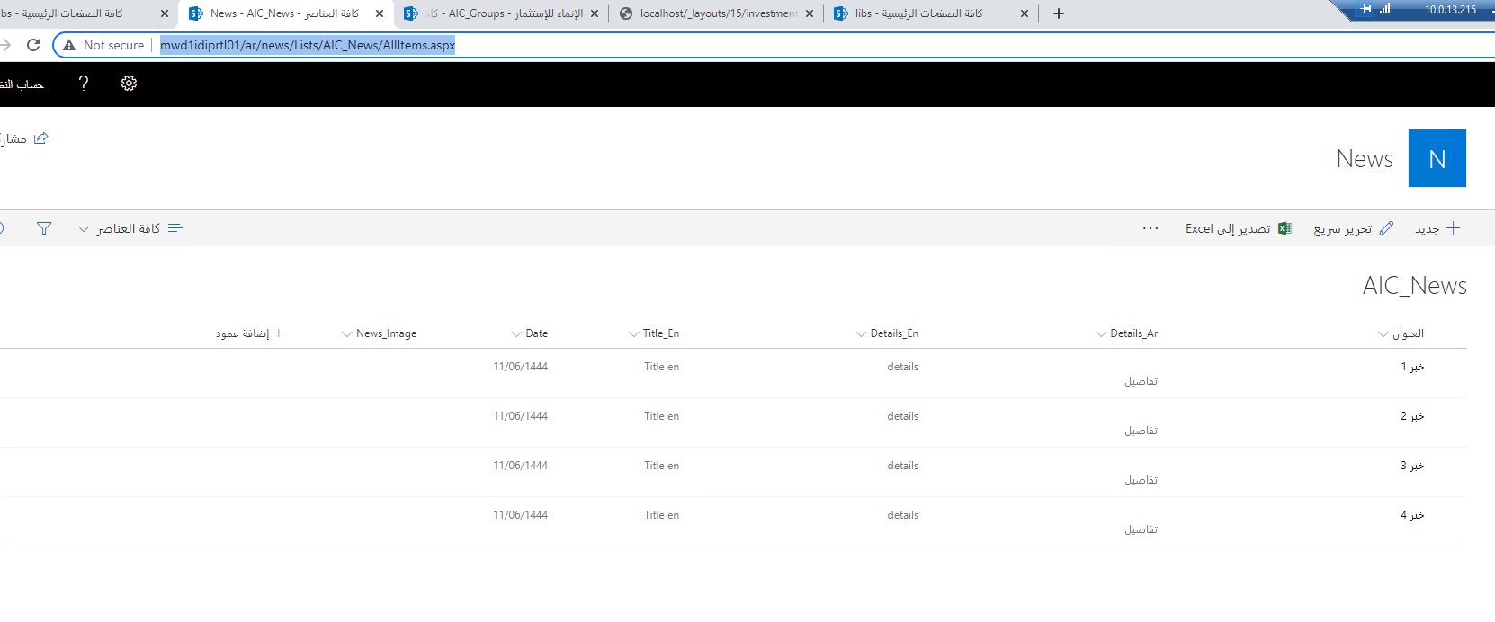

<http://mwd1idiprtl01/ar/Lists/AIC_Groups/AllItems.aspx>

